ACL proposes that NCLER ask legal and aging network professionals that receive Legal Training, Case Consultation, and Technical Assistance a series of survey questions presented in the web-based URSRT in order to properly assess audience targeting, participant satisfaction and outcomes of training and technical assistance delivery as required by the NCLER contract.
Survey Questions & General Information
- First and Last Name: Fillable field.
- E-mail address: Fillable field.
- State: Select from a drop-down menu.
- Organization Name: Fillable field.
- Type of Organization: Select from a drop-down menu.
» Title III-B Attorney
» Legal Services Corporation Attorney
» Other Legal Services Attorney
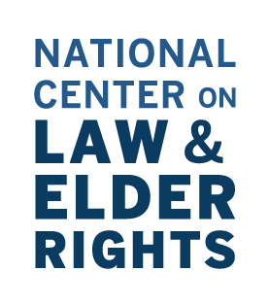
» Other Elder Law Attorney
» Other Legal Services Professional
» Aging and/or Disability Network Professional,
» Other
- Title: Select from a drop-down menu.
» Executive Director
» Management
» Staff Attorney
» Counselor
» Other
- Please rank the quality of assistance provided in this (Legal Training/Case Consultation/Technical Assistance): Select one of the following from a drop-down menu.
» Excellent
» Good
» Adequate
» Needs Improvement
» Poor
- Did the assistance provided by this (Legal Training/Case Consultation/Technical Assistance) contribute to a successful resolution of a specific client issue? Select one of the following from a drop-down menu.
» Strongly Agree
» Agree
» Agree Somewhat
» Disagree
» Strongly Disagree
- If requesting assistance on legal services delivery, will the assistance provided contribute to the successful completion of one or more of the following: legal needs and capacity assessments, legal services delivery plans, legal service delivery standards, or data collection/reporting systems? Select one of the following from a drop-down menu.
» Strongly Agree
» Agree
» Agree Somewhat
» Disagree
» Strongly Disagree
National Center on Law & Elder Rights | 2

