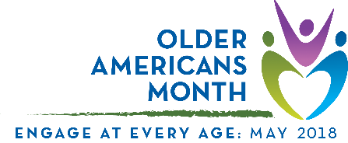

Proclamation TEMPLATE
Support from a mayor or governor can raise community awareness about Older Americans Month. Use this template to request public recognition by your local government officials. In addition to filling in placeholder information, edit the content to be as relevant as possible to your community.

Older Americans Month 2018
A Proclamation
Whereas, [community, area, or organization] includes countless older Americans who enrich and strengthen our community; and

Whereas, [community, area, or organization] is committed to engaging and supporting older adults, their families, and caregivers; and

Whereas, we acknowledge the importance of taking part in activities that promote physical, mental, and emotional well-being—no matter your age; and

Whereas, [community, area, or organization] can enrich the lives of individuals of every age by:
- promoting home- and community-based services that support independent living;
- involving older adults in community planning, events, and other activities; and
- providing opportunities for older adults to work, volunteer, learn, lead, and mentor.

Now therefore, [I/we] of [city/town, state] do hereby proclaim May 2018 to be Older Americans Month. [I/we] urge every resident to take time during this month to recognize older adults and the people who serve them as vital parts of our community.

Dated this [day] day of [month], 2018
[Name of person/entity approving proclamation]
[Seal, if applicable]

